BYLAWS

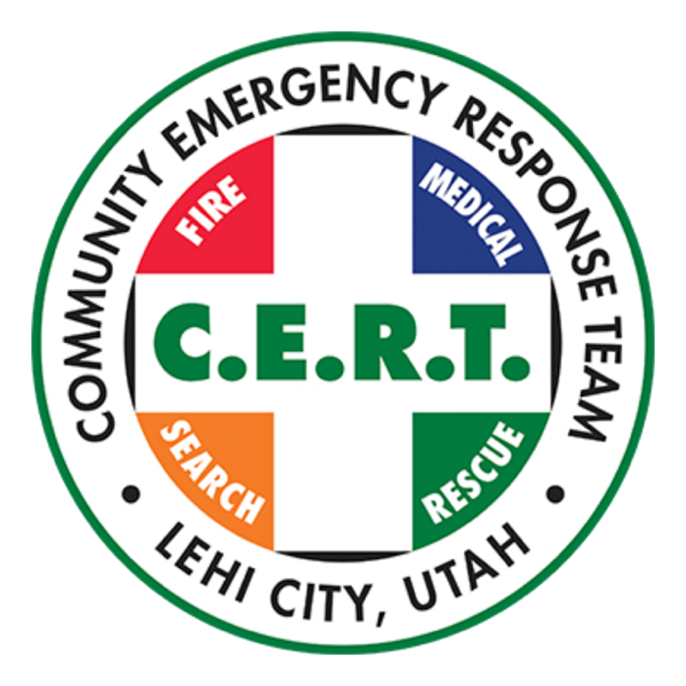

LEHI CERT TEAM

Voted and Approved, Jun 4, 2025
Updated: Dec 10, 2025
ARTICLE I
NAME AND ORGANIZATION
- The name of this organization is the LEHI COMMUNITY EMERGENCY RESPONSE TEAM (“LEHI CERT”).

- Lehi CERT is organized to provide voluntary support to first responder and emergency management services and to provide emergency response education to the community of Lehi, Utah.

ARTICLE II
AIMS AND OBJECTIVES
- The Aims and Objectives of Lehi CERT are and shall be:

  - To work with the Lehi Fire Department (“LFD”) and/or the Lehi City Emergency Management Department in providing volunteer support to emergency first responder services in Lehi City in Utah County, the State of Utah.

  - To provide emergency response educational services and preventive measures to improve the safety of the general public using local expertise and information and resources from the Federal Emergency Management Agency (FEMA).

  - To coordinate with local search and rescue units, first responders, law enforcement, emergency communication organizations, and other groups as needed in furtherance of these Aims and Objectives.

  - To associate with like-minded people together in meetings, gatherings, and in the field for the promotion of training and good fellowship.

ARTICLE III
MEMBERSHIP
- Any person meeting membership requirements who is at least 18 years of age shall be eligible to join Lehi CERT.

  - To become a Lehi CERT Team Member applicants must first complete Basic CERT Training consisting of two parts: a free online self-paced course (accessible here), and a hands-on course covering eight modules, provided by trained and authorized CERT Trainers, using the official CERT Basic Training Participant Manual (accessible here) or other CERT training as approved by the Board. Upon completion of both parts, a person is considered Basic CERT Trained.

  - To become a fully operational Lehi CERT Team Member, candidates must provide a current copy of a State of Utah background check* (instructions here). Team Members progress from being ‘CERT trained’ to a Lehi CERT Team Member (Level 1, 2, 3 and 4) with additional participation, experience, and by completing additional training and providing the Education Director with their course completion certificate (information here).

*A current Utah State background check done for school or employment purposes is considered valid for the purposes of Lehi CERT. A copy shall be provided to the Secretary.

- TEAM MEMBER: Any person who: has successfully completed the CERT Basic Training and has completed the Lehi CERT Level 1 requirements (information here), meets the Good Standing requirements; and is not objected to by the Board, will be a Team Member. Team Members have no leadership roles and no voting rights with Lehi CERT.

- Good Standing requirements for membership will be set by the Board of Directors (“Board”) and made available to the Lehi CERT membership.

- Any Lehi CERT Team Member who: shall be guilty of any act(s) reflecting discredit upon Lehi CERT or sponsoring agencies; fails to maintain Good Standing requirements; may be removed from Lehi CERT by the Board.

- Exceptions to the Good Standing requirements may be approved by the Board for reasonable justification, such as: documented medical condition or approved absences. Exceptions will be documented and available to the team membership.
ARTICLE IV
LEHI CERT LEADERSHIP
- THE BOARD

- The oversight of Lehi CERT is to be handled by the Board, which is composed of: Program Manager, Assistant Program Manager, Secretary, Financial Director, Education Director, Communication Director, and Division Director and other positions the Board may deem necessary.

- Any Board member may have more than one Board position as needed, but they only have one vote on the Board.

- Subsequent to the election of a new Program Manager, a slate of new Board Members is appointed by the new Executive Committee and serve a two-year term. Existing Board members may be reappointed to the same or other positions.

- The Chairman of the Board shall be the Program Manager, unless the majority of the Board votes to appoint another Team Member as Chairman.

- The Board Members each have a designated focus of responsibility and will work with the Executive Committee to provide direction, guidance, supervision, and approval of the execution of those responsibilities.

- A Board Member may resign at any time, for any reason, without effect on their membership status. A Board Member may be removed from the Board at any time by a showing of good cause and a majority vote of the Board.

- Board Members are not provided with liability insurance and Lehi CERT makes no representation absolving any Board Member of liability.

- EXECUTIVE COMMITTEE

  - The Executive Committee is composed of the Program Manager, Assistant Program Manager, and Secretary.

  - The Executive Committee provides leadership, direction, and ongoing management to the organization. Executive Committee members keep each other informed regarding their individual responsibilities, interactions, and dealings with team matters.

  - A member of the Executive Committee may resign at any time, for any reason, without effect on their membership status. A member of the Executive Committee may be removed at any time by a showing of good cause and a majority vote of the Board.

- OFFICERS

  - The PROGRAM MANAGER shall be elected by the existing Board. A Team Member in good standing may be nominated by any Team Member (or themselves), after which an election shall take place. Only active Team Members (Level 1 and above*) may be nominated for the position of Program Manager.

    - The new Program Manager agrees to take CERT Program Manager training as soon as possible, if they have not done so already.

    - Elections for Program Manager shall be held every two years in November, or other time as voted upon by the Board, with new officers beginning their term on January 1st at the beginning of the following year.

  - The ASSISTANT PROGRAM MANAGER will be elected following the procedure described above for the Program Manager.

  - Should the Program Manager or Assistant Program Manager be unable to fill their term, the Board may appoint a replacement or hold new elections to finish out the term.

  - The Financial Director, Education Director, Communication Director, Secretary, and Division Director shall be appointed by the Executive Committee and ratified by a majority vote of the Board.

  - An Executive Officer may resign at any time, for any reason, without effect on their membership status. An Executive Officer may be removed at any time by a showing of good cause and a majority vote of the Executive Committee.

*If nominee is not currently a Level 1 (or above) member, they commit to completing Level 1 before taking office.

ARTICLE V
DUTIES OF OFFICERS
- The Program Manager shall have the following duties:
  - Preside over Board meetings, Executive Committee meetings and Team Member meetings;
  - Liaise with both the Lehi Fire Department and the Lehi City Emergency Management Department;
  - Execute directions of the Board;
  - Carry out the directions of the Executive Committee;
  - Engage with the other officers and directors on accomplishing their responsibilities;
  - And shall perform the duties required in the management of the external or internal affairs of Lehi CERT in support of its Aims and Objectives.

- The Assistant Program Manager shall have the following duties:
  - Lead meetings as directed by or in the absence of the Program Manager;
  - Oversee training needs of existing and potential Team Members;
  - Engage with the other officers to assist in their accomplishing their responsibilities;
  - And shall perform the duties as directed by the Program Manager required in the management of the external or internal affairs of Lehi CERT in support of its Aims and Objectives.

- The Finance Director (Treasurer) shall have the following duties:
  - Oversee financial responsibilities for and in behalf of Lehi CERT including but not limited to bookkeeping duties, tax duties, and includes managing the bank accounts of Lehi CERT, and accounts on Donorbox, Stripe, Paypal and other financial systems used by the organization;
  - Engage with the other officers to assist in their accomplishing their responsibilities;
  - And shall perform the duties required in the management of the external or internal affairs of Lehi CERT in support of its Aims and Objectives.

- The Secretary shall have the following duties:
  - Lead meetings as directed by or in the absence of the Program Manager and the Assistant Program Manager.
  - Maintain all membership records, meeting notes and records, and event records;
  - Provide email and text communications with Team Members to notify of meetings and activities;
  - Provide reminders to Team Members of assignments and action items;
  - Engage with the other officers to assist in their accomplishing their responsibilities;
  - And shall perform the duties required in the management of the external or internal affairs of Lehi CERT in support of its Aims and Objectives.

- The Division Director shall have the following duties:
  - Oversee Division Leaders in the execution of their responsibilities;
  - Provide training to Division Leaders;
  - Engage with the other officers to assist in their accomplishing their responsibilities;
  - And shall perform the duties required in the management of the external or internal affairs of Lehi CERT in support of its Aims and Objectives.

- The Education Director shall have the following duties:
  - Oversee training programs and other training responsibilities;
  - Update Team Members on training opportunities;
  - Coordinate with Secretary to update membership training completion records;
  - Engage with the other officers to assist in their accomplishing their responsibilities;
  - Take CERT Train the Trainer course as soon as possible if not already done;
  - And shall perform the duties required in the management of the external or internal affairs of Lehi CERT in support of its Aims and Objectives.

- The Communications Director shall have the following duties:
  - Oversee the texting, radio, and other communications responsibilities and specifically, oversee the LCARC (Lehi CERT Amateur Radio Club) and the monthly LCARC Net;
  - Engage with the other officers to assist in their accomplishing their responsibilities;
  - And shall perform the duties required in the management of the external or internal affairs of Lehi CERT in support of its Aims and Objectives.

ARTICLE VI
MEETINGS AND REPORTING
- The Chairman of the Board will determine the timing and location of any scheduled or special meetings of the Board.

- The Lehi CERT Board shall hold meetings quarterly or as determined by the Board. Notification of any meeting of the Board will be given to Board Members at least 24 hours in advance via email, text, or telephone.

- Conferencing technology or phone bridge may be used for meetings and remote participants are considered present.

- A majority of the staffed members of the Board are required to form a quorum for Board meetings. The Executive Committee requires three (3) or all members, whichever is less, to form a quorum.

- Team Members may be asked from time to time to serve in ad-hoc committees, fulfill specialist roles, or in other ways provide services to the Team. These positions do not confer any special rights or privileges beyond what is defined in these Bylaws.

- Records shall be kept of the proceedings of all meetings by the Secretary or designated Team Member. All meeting notes shall be retained by the Secretary. These records shall be available for review by any Team Member.

- The Program Manager and Assistant Program Manager (or other members of the Board as requested) shall meet with the Lehi Fire Department and/or the Lehi City Emergency Management Department as needed to coordinate activities, responsibilities, and expectations of Lehi CERT in alignment with its Aims and Objectives.

- Relevant activities and business of Lehi CERT will be communicated to the Lehi Fire Department and/or the Lehi City Emergency Management Department on a regular basis, such as event summary reports, including volunteer activities and hours; medical or other incidents; Lehi CERT assignments, planning, training and other activities as appropriate.

ARTICLE VII
FINANCES, FEES, AND DUES
- The fiscal year for Lehi CERT shall begin July 1 of each year.

- Management of Lehi CERT funds shall be as follows:

  - Monies received from all sources shall immediately be turned over to the Finance Director, or delegated position by the Finance Director, to deposit in the accounts of Lehi CERT.

  - No withdrawal of funds shall be made without the approval of the Program Manager or Assistant Program Manager. Approval may be obtained during meetings with notes being taken, or by email or text, preserving a written evidence of approval.

  - Records shall be maintained for all payments made by Lehi CERT whether made by check, debit card or electronic payment.

- Team Members, Board Members, and Officers are volunteers and will not be compensated for their time or reimbursed for their personal expenses related to their activity on the team.

- Dues may be established by the Board at a level sufficient to cover the needs of Lehi CERT. Dues may be optional or required at the discretion of the Board.

ARTICLE VIII
OFFICIAL PROCEDURE
- Robert’s Rules of Order shall govern the parliamentary procedure where the Articles of Incorporation or the Bylaws are silent on the question.

ARTICLE IX
POLICIES, STANDARDS AND AMENDMENTS
- The Policies and Standards of Lehi CERT will be maintained by the Executive Committee and approved by the Board. Approved Policies and Standards will be published, and all Team Members will be required to abide by them.

- These Bylaws may be amended by a majority vote of the Board with written notice of all proposed changes five (5) days in advance of the applicable meeting. Proposed changes must be submitted by a Board member.

ARTICLE X
DISSOLUTION
- Dissolution may occur by a two-thirds vote of the Board. At any time, the Board may vote on merging with another local CERT organization.

- Upon dissolution of Lehi CERT (or a merger), after settling any financial obligations incurred by the team, its assets shall be distributed to any charitable organization in the State of Utah which qualifies for exemption under Section 501, Internal Revenue Code of 1986, as amended, and according to a plan of distribution approved by the Board, or if a merger, assets may be merged with the new CERT Organization.

ARTICLE XI
AMENDMENTS TO BYLAWS
- These Bylaws may be altered, amended, or repealed and new bylaws may be adopted by a majority of the Board present at any regular or special Board meeting.

- These Bylaws were approved and passed by the Board of Directors, June 4, 2025:

BYLAWS APPROVED AND SIGNED BY:

Steven Boyack ______________________________
Program Manager

Tony Strickland _____________________________
Assistant Program Manager

David Crowther ______________________________
Secretary

Wendy Shoop ______________________________
Education Director

Merrilee Boyack ______________________________
Division Director

